Alexander Baldree

07/28/26

Module 11.1 Discussion Board

CSD430

What
As I continued working with Java projects, I started to understand why Maven is commonly mentioned alongside Java. One important thing I learned is that Maven is not actually a programming language. Java is the programming language used to write the application, while Maven is a build and project-management tool that helps organize, compile, test, and package the Java code. Maven was created to give developers a standard way to build projects, describe what a project contains, and share libraries between different projects.
Maven manages a project through a file named pom.xml, which stands for Project Object Model. This file contains information such as the project name, version, Java version, plugins, and external libraries needed by the application. Maven also encourages developers to follow a standard folder structure. The main Java code is normally placed in src/main/java, while test code is placed in src/test/java.

How
Maven is relevant to Java because it handles many of the steps that happen around writing Java code. Java allows me to create classes, methods, objects, and the actual logic of the program. Maven then helps take that code and turn it into a working application. Maven uses a build lifecycle, which means commands such as compile, test, and package follow a defined process. For example, running mvn clean package can remove the previous build, compile the source code, run the tests, and create a JAR or WAR file.
A simple pom.xml file would look like this:
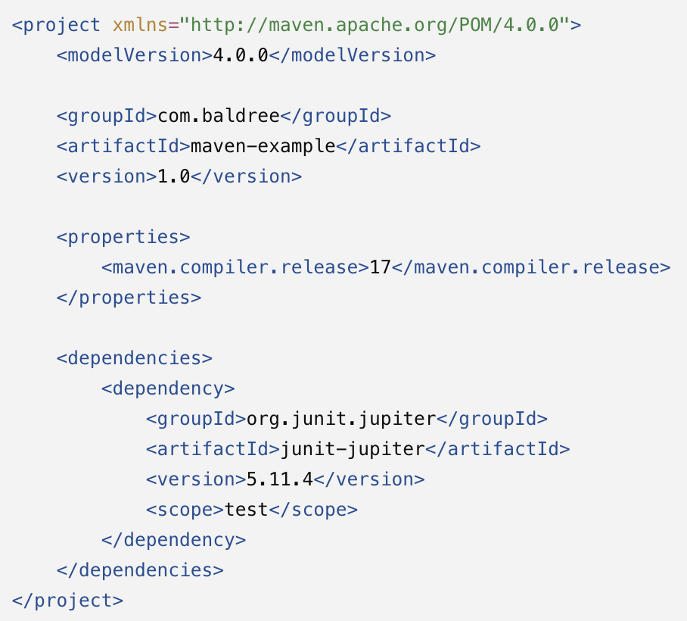
This tells Maven that the project uses Java 17 and needs JUnit for testing. Instead of manually downloading the JUnit files and placing them into the project, Maven can locate and manage the dependency through its repository system.

Why
The biggest advantage I have found with Maven is that it keeps a Java project organized and makes the build process repeatable. Another developer can download the project, open the pom.xml file, and use the same Maven commands that I used. Maven also makes dependencies easier to manage because their names and versions are recorded in one location. This becomes especially useful when a project starts using database connectors, testing frameworks, logging libraries, JavaFX, or other outside tools.
Maven also has disadvantages. The pom.xml file can become long and difficult to understand as more dependencies and plugins are added. I have also experienced Maven errors caused by missing dependencies, incorrect plugin versions, or running a command from a directory that did not contain the pom.xml file. Maven may spend time downloading files during the first build, and some of its error messages can be confusing when I do not know which plugin or dependency caused the problem.
Because Maven and Java perform different jobs, I would not describe Maven as a replacement for Java. I still need Java to create the program. Maven simply gives me a more consistent way to manage everything surrounding that program. Believe Maven is worth using for medium or large Java projects because the organization, dependency management, testing support, and repeatable builds usually outweigh the additional setup and troubleshooting.

References
Apache Maven Project. (n.d.). Introduction to the build lifecycle. https://maven.apache.org/guides/introduction/introduction-to-the-lifecycle.html
Apache Maven Project. (n.d.). Introduction to the dependency mechanism. https://maven.apache.org/guides/introduction/introduction-to-dependency-mechanism.html
Apache Maven Project. (n.d.). Introduction to the standard directory layout. https://maven.apache.org/guides/introduction/introduction-to-the-standard-directory-layout.html
Apache Maven Project. (n.d.). What is Maven? https://maven.apache.org/what-is-maven.html

